Automatic staircase light using PIR Sensor and Relay

Introduction

This **automatic staircase light circuit** switch on the staircase lights automatically when someone enters on the stairs and gets off after some time. There are two important components in this circuit, first is **PIR Sensor** (Passive Infrared Sensor) and second relay.

**PIR Sensor**

PIR sensor is used here to detect the Human body movement, whenever there is any body movement the voltage at output pin changes. Basically it detects the Change in Heat, and produce output whenever such detection occurs. You can learn more about [PIR sensor here](http://circuitdigest.com/electronic-circuits/pir-sensor-based-motion-detector-sensor-circuit), there are some useful features in PIR sensor like how to change the distance range, how to set the duration for which the light should be ON etc

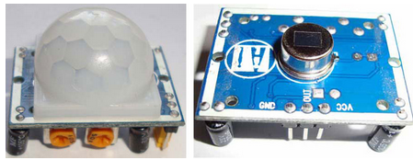

**Relay**

[Relay](https://circuitdigest.com/article/relay-working-types-operation-applications) is an electromagnetic switch, which is controlled by small current, and used to switch ON and OFF relatively much larger current. Means by applying small current we can switch ON the relay which allow much larger current to flow. Relay is the good example of controlling the AC (alternate current) devices, using a much smaller DC current.  Commonly used Relay is **Single Pole Double Throw (SPDT)** Relay, it has five terminals as below:

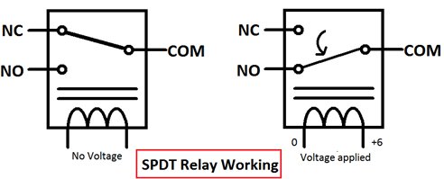

**Relay**

[Relay](https://circuitdigest.com/article/relay-working-types-operation-applications) is an electromagnetic switch, which is controlled by small current, and used to switch ON and OFF relatively much larger current. Means by applying small current we can switch ON the relay which allow much larger current to flow. Relay is the good example of controlling the AC (alternate current) devices, using a much smaller DC current.  Commonly used Relay is **Single Pole Double Throw (SPDT)** Relay, it has five terminals as above.

WORKING PRINCIPLE:

We all know that one of the places where power wastage occurs most in homes and offices is at staircases. We usually turn on light at stairs and leave it in a hurry. In this project we are going to design a **stair case lamp** which works on battery and only turn on the lights only when someone is present at there. This circuit can be used to save power and it can be used as an

The circuit works on two conditions - one is presence of light in its location and second is presence of human being, only when these two conditions are met, the controller turns the backup light ON.

These two conditions are tested by two sensors one is LDR and other is PIR Motion sensor module. The LDR senses the presence of light and Motion sensor detects the presence of a human being in its range.

code

int sensor = 7;

int led = 5;

int val;

void setup() {

pinMode(sensor,INPUT);

pinMode(led,OUTPUT);// put your setup code here, to run once:

}

void loop() {

val=digitalRead(7);

if (val==1)

{digitalWrite(led,HIGH);

delay(5000);

}// put your main code here, to run repeatedly:

if(val==0)

{

digitalWrite(led,LOW);

}

}